Guide to using qGene Analysis R Script

Howdy folks 🤠 this simple document will explain how to use the qGene Analysis RScript for processing calculation of Mean normalized transcript expression from duplicate qPCR results from multiple files. It will provide insights/caveats which may be useful for saving time when using the script.

Note this currently uses standard Amp. Efficiency curves for calculation of MNE.

**Contents**

**How to prepare/layout Dataset for analysis** 2

**Using the Script** 3

**Settings you can change** 3

**Troubleshooting** 3

# **How to prepare/layout Dataset for analysis**

**Before you start: Make sure your data is formatted correctly. Important to make sure all the labels on the samples are consistent for the primers used.**

1. There is an excel template in this folder (currently “WolDens Analysis Template”) outlining how to layout your data which may be of use.
2. You can take the output from the QIAGEN rotorgene software and re-format if necessary to match this format.
3. Make sure the file is a **csv**
4. Data layout prerequisites:
   1. Your csv file should consist of columns:
      1. Name,
      2. Take Off,
      3. Amplification,
      4. 2nd Deriv. Max.
      5. Rep. Takeoff,
      6. Rep. Takeoff (Std. Dev.)
5. Example template layout: The colours are to demonstrate the same sample with both technical replicatesA yellow purple and blue numbers

   Description automatically generated

# **Using the Script**

1. The script is available on the group drive. Protocols> Rscript for qGene Analysis > qGene Analysis Script (Simplex) v2 AKA
2. Open the RStudio Script (take a copy and save onto your PC or Drive)
   1. Set-up an R project in a folder containing this script and several other folders
      1. data
         1. repeats
         2. analysed
         3. raw
         4. log
3. Confirm the Amp. Efficiencies are correct (default is WOL/RpL32)
4. Change the names of the house keeping and target genes (you will need to do this in the actual code, command+F WOL and replace all with your target gene name and do the same for rpl if it is a different gene you are using
5. Change the file path in the IMPORTING RAW DATA section
6. Run the code
7. **Three** **outputs** will be produced by default
   1. An announcement of any Samples censored from the data due to high SEM%, like below.



* 1. A dataframe containing all **non-censored** samples and their results.

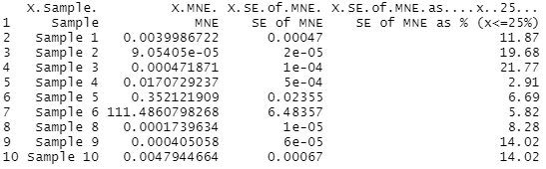

* 1. A dataframe containing all **censored** samples and their results.



1. The code also saves two files
   1. 1. A csv file with all those samples that passed QC that you can used for futher analysis/graphing (this is saved in the data > analysed folder)
   2. 2. A csv file with all those samples that **failed** QC that need to be repeated including the reason for repeating and what approach to use for the repeat. (this is saved in the data > repeats folder)

# **Settings you can change**

1. Change UseCutoff line to = 0 if you do not wish to censor data based off SEM%.
2. Change SEMCutoff to alter the maximum acceptable SEM%.

# **Troubleshooting**

1. Note that if your Datafile name starts with a number (E.g. 12345), upon import R will rename it X12345, and you will have to include the X in the Data <- line. (E.g. Data <- X12345)
2. Upon first use the two rm() lines towards the top will return errors, this doesn’t matter.